Abstract

We're trying to make a new connected car technology that will allow the vehicle to identify the location and severity of potholes, broken drains, man hole covers, and then share this data in real time with other vehicles or with road authorities to help them prioritize repairs or inform both so the vehicles will be loaded with capable sensors which monitors the road surface. For example, while you are driving they're monitoring what's happening on the road and they'll be able to categorize potholes and see which ones are the most severe and also attach locations to these but then we can share this location to other cars through GPS and to Road Authorities to prioritize the repairs using cellular communication we can take anonymize  data so the location and severity of the pot holes and share it in the cloud and then as other users on the road come along we can actually provide that data back to them to warn them about the pot hole, this reduces the number of accidents and also helps the Road Authorities to know that there is a problem which needs to be solved as soon as possible.

**Introduction**:-

One of the increasing problems the roads are facing is worsened road conditions. Because of many reasons like rains, oil spills, road accidents or inevitable wear and tear make the road difficult to drive upon. Unexpected hurdles on road may cause more accidents. Also because of the bad road conditions, fuel consumption of the vehicle increases; causing wastage of precious fuel.

Because of these reasons it is very important to get the information of such bad road conditions, Collect this information and distribute it to other vehicles, which in turn can warn the road authorities about the problem based on number of signals received about the same route in a particular time priority to repair is road is increased

PotHole Detection System:

Pothole detection system is a system that aims at warning the road authorities about the uneven roads and potholes in various paths that are used very frequently by huge number of people and which cause accidents frequently. We study the different ways in which goal of the system can be achieved. We justify the methods we have chosen in this project. And then we give details about the working of the different subsystems .Access points responsible for storing the information about potholes in its vicinity, taking the feedback from vehicles, updating the information in repository and broadcasting the information to other vehicles. Whereas Mobile node which is the small device placed in vehicle is responsible for sensing those potholes which it did not have previous information about, locating and warning the authorities about the potholes which it has information about, and giving the data about newly sensed pothole to access point.

Challenges Involved:

There are various challenges involved in this project.

• Client device must be able to sense the pothole. It will be an added advantage if it can characterize the pothole telling how severe it is.

• Placement of access points is an important factor. It should be in such a way that the data should be distributed to maximum vehicles.

• Communication between access point and client device can have many problems which should be resolved. Some of the problems that communication can face are interference, Low throughput due to large no of client devices, end to end reliability.

• Data representation should be in such a way that the client device should be able to locate the device precisely so that required actions can be taken.

Architectural Design:

System consists of three subsystems: Sensing, Communication, Localization. These three subsystems work independent of each other, but have one center point they revolve around; that is data. Sensing system generates the data; Communication collects, co-ordinates and distributes the data; lastly Localization uses the data and generates information for the driver. The overall design

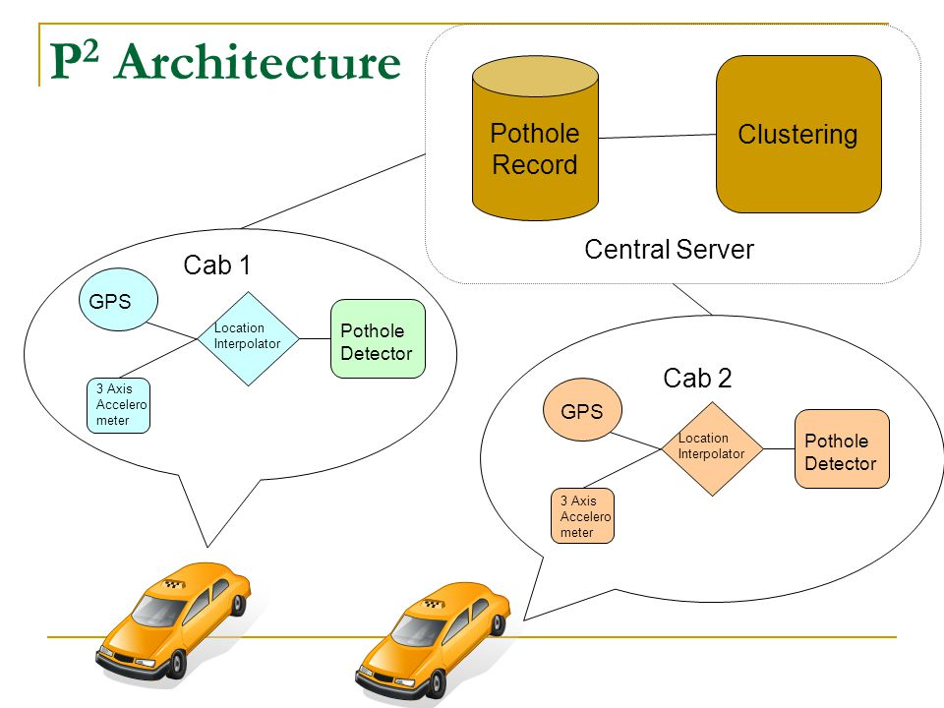

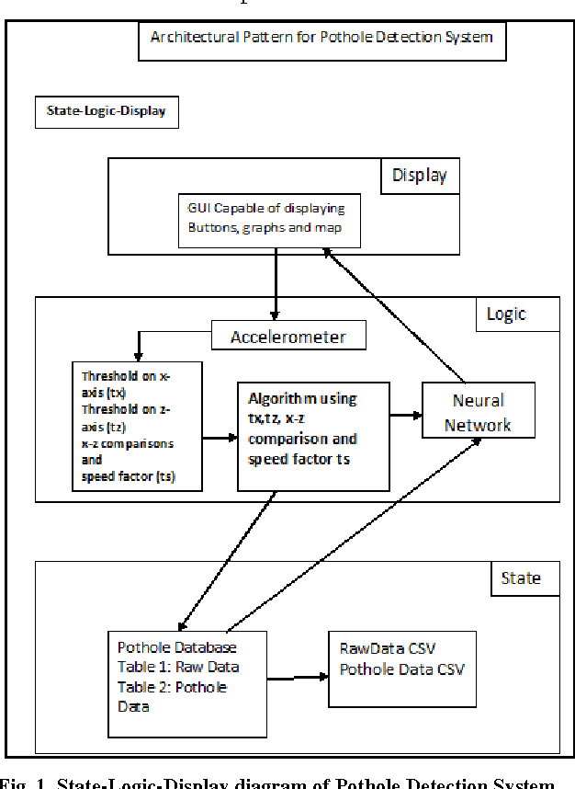

Sensing Subsystem:

This subsystem is responsible for getting the data. The data in this case would be the data about pothole e.g. location of pothole, the severity of the pothole. There were two methods under consideration for this subsystem one is Vision based and the other is vibration based.

Vision-based method:

This method uses 'Camera' as sensor to scan the road for any potholes. The camera captures the images in real time. These images are applied to image processing algorithms like edge detection. This requires lot of processing time and power. There many design approaches possible. Hardware based methods like use of special Digital Signal Processors or Application Specific Integrated Circuits improve the performance over software based method. But still the response time of the operations required like windowing convolution for the image processing algorithm is still large. This method has one advantage over the other is, it can sense a pothole without experiencing it i.e. Vehicle does not actually has to pass through the pot hole to sense it. Characterization of pothole can be done on the basis of size of the pothole. Some other vision based methods for obstacle detection are RADAR [8] but they have little use in pothole detection.

Vibration based method:

This method uses 'Accelerometer' to sense potholes.

Accelerometer:

This is a device that measures total specific external force on the sensor. For example if the device is stationary, it will show some reading corresponding to earth's gravitational force. An accelerometer falling freely in the vacuum will show zero reading. The design of the accelerometer is often very simple. The simplest design can be a mass hanging by a thread and some sensor to measure its deflection for original. The device is popularly used to measure vibration or inclination. It is popularly used in iTouch and some cameras to detect inclination and change the view of the display. Accelerometer The accelerometer device we are using for our project is LIS3L06AL[4] by ST. It can measure acceleration on three perpendicularly placed axes. It can measure acceleration up to 6g. Pothole induced vibrations can generally be measured on the vertical (z) axis readings. We can characterize the pothole on the basis of the magnitude of change in reading of accelerometer.

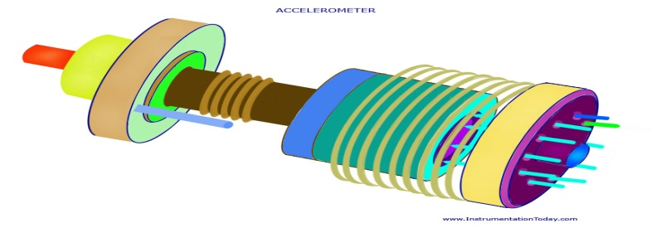

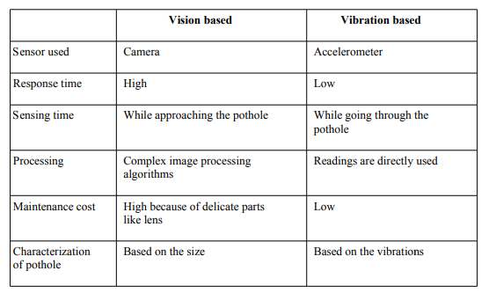

Comparison between different sensing methods

Here we choose the second method that is Vibrations based approach given the low response time, processing time and maintenance cost of the device.

Public transport as Access point:

In this approach we use Public transport such as Buses for city or town coverage or ST buses for highway coverage. In this approach Access point itself is moving. Conversely in our approach we are using public transport for distributing the data to other vehicles. In this case access point itself is moving , hence we can provide a Sensor device to access point. This will save per private vehicle cost of device by exempting them from sensing application. Public transport vehicle will sense the potholes on its path and broadcast information about that to the other vehicles passing by. Vehicles equipped with the client device can receive this data. But this approach has several problems. The coverage is not vast. As information about only those potholes are available which are covered by public transport and there may be roads on which the buses don't commute. Also bus only has information about its own route which may or may not be useful for the vehicle as Vehicle can take any path. So vehicle must have some way by which they know which data will be useful for them.

Comparison between communication approaches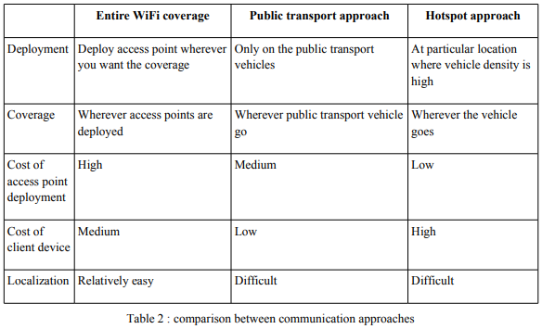 Localization subsystem:

Localization subsystem uses the data given by access point to actually find the location of the pothole and warn the driver about it. As we explained earlier Localization is especially challenging in the situation we selected. Because there is no access point situated near the location of the pothole. So vehicle has to find its own way. GPS (Global positioning system) : As we all know this is a very popular location finding system. It is also the first and till recently the only global and fully functional location finding system[5]. It is based on the communication with 24 satellite orbiting around the earth. It works as follows. These 24 satellites are revolving around earth in 6 different paths. Theoretically at any point you need a point to point connection with at least 4 satellites to get your position. 7 It basically takes 4 measurements to determine 4 parameters x,y,z,t. And then represents in the form understood by the user like latitude/longitude. In real setting It might even require less satellites if one of the parameters is known. For example ships sailing in sea know there altitude to be zero. Also more the satellites you can connect to more accurate location you will get. GPS locations can get as accurate as up to 15meters. So in our system data about potholes is stored in terms of x,y,z parameter. Also a long length of a bad road maybe saved as a [(x1,y1,z1),(x2,y2,z2)] which indicate the start and end of a bad road. This data can be used by vehicles directly. As when they get the data from the access point the places where potholes are there can be shown distinctly on the GPS map. According to severity of the pothole or road it can be shown with different brightness. Also when vehicle senses a new pothole it stores the corresponding GPS parameters in its local memory and gives as a feedback to immediate next Access point.. But there are several problem with this technology. First of all it is highly expensive. Not just for maintaining but even the GPS receiver is costly. Another problems with GPS is it needs a clear view of orbiting satellite; so it does not work properly in-doors and mainly in the newly forming urban canyons where it is needed the most. Also it has a high operational cost if it is made to work in real time, as it needs to update its location at real time.

Accelerometer characterization:

As we said before we have used an accelerometer as a vibration sensor. Now there are some issues with the its of characterization as follows.

• Characterization of potholes and roads can be done using the readings of the accelerometer.

• In accelerometer device there is always earth's acceleration 'g' acting on device in vertical direction. Usually it is also subtracted with the offset. But we in our experiments can not do it because in our case it depends on the terrain on which the vehicle is driven. If the vehicle is on the slope this 'g' gets divided in two axes. In this scenario the vibration readings in vertical axis it will read less than actual.

Deployment of the sensor in vehicle:

When the accelerometer is deployed on the vehicle there are many things that should be taken into consideration to get the accurate reading.

• When the accelerometer is deployed in a real vehicle its reading might be biased because of the shock absorption system of the vehicle reduces the effect of the potholes. So the actual readings are also based on how good shock absorption system vehicle has. Or the placement of accelerometer should be such that the effect of shock absorption is minimal.

• Also the different placement of the accelerometer would give different readings. For example we keep device in the boot(at the back of the vehicle) vibrations will be more compared to the front.

• For large vehicle such as Trucks or ST buses; Readings at both front and back might be very different and both maybe important in order to characterize the span the road. So more than one accelerometer are need for characterization.

Communication Subsystem:

The communication subsystem as said earlier is backbone of the system. It involves communication between vehicle and Access point deployed as hotspot. Firstly broadcast of the hotspot, and then The feedback given by vehicles. These vehicles might be moving, might be stationary(e.g. stopped at signal). Some issues involved in this are:

• Throughput of the system depends on speed of the moving vehicle. It has been shown by experimentation that data transferred reduces from average of 58MB at 5mph to 3.8MB at 75mph[1]. This reduction is also because of the protocols that we use in general networking need handshaking which is an extra overhead when wireless network is concerned.

• At any point there maybe large number of vehicle which have some feedback to give. And as the number of vehicle increase the throughput decreases. Hence less and less feedback will reach access point.

• If we use standard CSMA/CA there might be a case where Access point itself gets the medium busy. Because of this the new vehicles(just entering the hotspot range) might not get the data for long time because existing vehicles are giving feedback.

• As the standard communication frequency for WiFI is 2,4GHz There might be interference from many devices in the vicinity such as bluetooth devices, cordless phones in the range.

• End to end reliability is also not provided in broadcast communication, as getting the ACK for data is not possible. In these scenarios transferring the data accurately is difficult. Some significant attempts stating the possible solution have been made, like data fountains[6,7] Localization : The localization system that we are using has some problems. It imposes a restriction that, Every vehicle using this system must have a GPS receiver. This increases the overall cost of the system. Hence we have to find some low cost method for locating potholes.

Details of the experiments performed Smooth road with bumps:

On a smooth road we placed some pins to generate the bumps. Then we ran FireBird over such road. And as shown in the graph below we got sudden change or spikes in the readings on at least one of the axis.

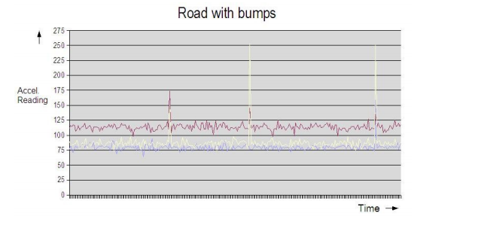

Uneven road:

For this the FireBird was run on three types of road smooth, moderately uneven road and highly uneven road. The graphs produced are as follows.

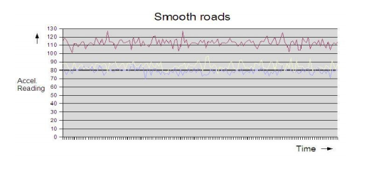

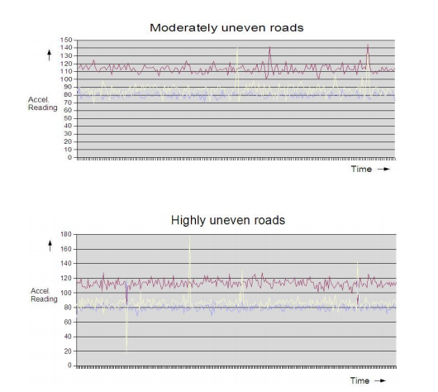

Vibrations were seen to be increased in terms of the accelerometer reading. Standard deviation of at least one of the Axis was increased significantly when we made the road conditions increasingly worse. Whereas large difference was found between readings of smooth road and moderately uneven roads.

Communication between Access point and vehicle:

It is very resources and time consuming to perform actual experiments on the large number of vehicles. So we are using simulation for this purpose.

Simulation of General scenario:

In this experiment with a usual settings. we model the exact drop of throughput with the increase in number of vehicles. We have to model this scenario for different number of stationary and moving vehicles. Speed of the vehicles is also one of the factor which can affect the throughput for a particular vehicle. For example if a vehicle with high speed wants to give feedback. But for the small time it was in the range of accelerometer; it never got free channel. Performance of system in terms of per vehicle feedback and number of vehicle which got the access point broadcast correctly must be measured.

Use of different channels:

Different channels also can be used for communication in each direction. Wi-Fi can be configured to work in 11 different channels out of which 3 are orthogonal (1, 6, 11). This will even reduce the interference per direction of the system. We can have Access point broadcast on one channel, and vehicle broadcasting on one channel. This will at least ensure that no vehicle is starving for data. On the other hand when all vehicles get data, more vehicle can generate the feedback this will flood the channel used in the direction vehicle to access point further reducing the throughput. These trade-offs must be studied

Summary:

Various choices for implementing the System have been studied. These choices were also compared to each other on various criterions. We have specified the High level design choices of the Subsystems and justified the corresponding selections. We did experiments on the platform called Firebird. We were also able to characterize road condition into categories like smooth, moderately uneven and highly uneven from the results of the experiments.